BOYNTON BEACH POLICE DEPARTMENT
OFFICE OF MEDIA RELATIONS
 | Michael G. Gregory |  | 2045 High Ridge Road  Boynton Beach, FL 33426  Phone (561) 742-6191
 | Chief of Police

A CFA Accredited Law Enforcement Agency

 |  | Stephanie Slater  Public Information Officer  SLATERS@BBFL.US  (561) 436-4806 | FOR IMMEDIATE RELEASE  Aug. 5, 2019

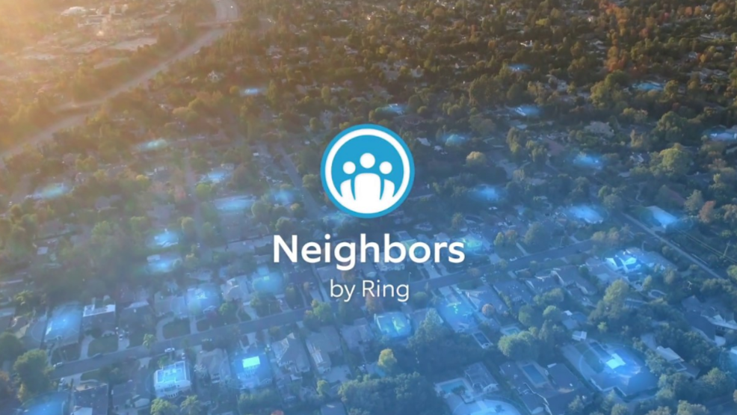

Boynton Beach Police joins Neighbors by Ring to provide community with
real-time, local crime and safety information

The Boynton Beach Police Department today announced that it is joining the free Neighbors app by Ring to provide the community with real-time, local crime and safety information.
Residents can text ‘bbfl’ to 555888 from their smartphone to download the Neighbors app for free on iOS and Android and use the app to; join their neighborhood, share crime and safety-related videos, photos and text-based posts; and receive real-time safety alerts from their neighbors, local law enforcement and the Ring team.
The Neighbors network already has millions of users and has been instrumental in catching package thieves, stopping burglaries, and keeping neighborhoods safe.
“We are excited about our partnership with Ring, which is another valuable tool for us to further reduce crime in the City of Boynton Beach,” Police Chief Michael G. Gregory said. “Community engagement is a key factor in crime prevention, and using the Neighbors App gives us additional opportunities to strengthen our efforts.”
Jamie Siminoff, Chief Inventor and Founder of Ring, said: “We’re excited to have the Boynton Beach Police Department join Neighbors to keep their community up-to-date on local crime and safety information. Over the past few years we have learned that, when neighbors, the Ring team and law enforcement all work together, we can create safer communities. Neighbors is meant to facilitate real-time communication between these groups, while maintaining neighbor privacy first and foremost. By bringing security to every neighbor with the free Neighbors app, the Boynton Beach community can stay on top of crime and safety alerts as they happen.”

How It Works
- Text ‘bbfl’ to 555888 or click here: https://download.ring.com/boyntonbeach from your smartphone to download the app for free on iOS and Android.
- Opt-in to join your neighborhood.
- Customize the geographic area you want to receive notifications for (users must verify where they are located and cannot participate in other neighborhoods).
- Receive real-time alerts from your neighbors, local law enforcement and the Ring team that inform of crime and safety alerts as they happen.
- View local crime and safety posts via a live feed or interactive map.
- Share text updates, photos and videos taken on any device, including Ring’s home security devices.
- Work with your community to make neighborhoods safer.

